**EXERCISE - DEVELOP A JAVA PROGRAM USING CONSTRUCTOR OVERLOADING**

**Problem Statement:**

**Objective:**

To understand the usage and the implementation of constructor overloading

**Problem Description:**

Enigma has recently opened its internet services in India. The company wants users to register for their internet services. But for the authentication of the user, the company has set criteria as below:

* The customer name and two phone numbers (one alternate phone number) are compulsory fields.
* The user should have a passport. If the user is not having a passport, he/she can provide anyone of the following combinations:
* License number and pan card number.
* Voter id and license number.
* Pan card and voter id.

The class diagram is as shown below:

**Registration:**

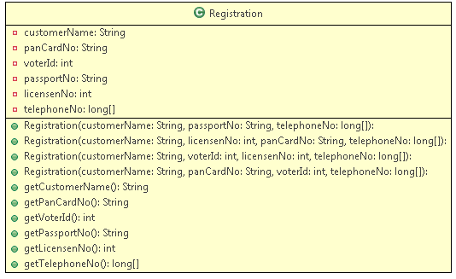

There are different users who want to register for this service and they satisfy one of the above criteria.

Write a tester class to implement your code.

**Input:**

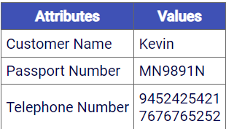

**Output:**

Congratulations Kevin!!! you have been successfully registered for our services with the following details:

Passport number: MN989IN

Phone numbers: 9452425421

7676765252

**Input:**

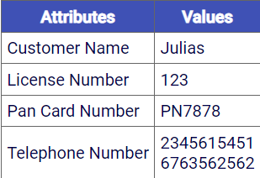

**Output:**

Congratulations Julias!!! you have been successfully registered for our services with the following details:

License number: 123

Pan card number: PN7878

Phone numbers: 2345615451

6763562562

**Input:**

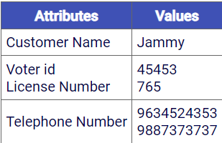

**Output:**

Congratulations Jammy!!! you have been successfully registered for our services with the following details:

Voter id: 45453

License Number: 765

Phone numbers: 9634524353

9887373737

**Input:**

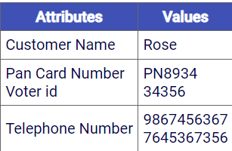

**Output:**

Congratulations Rose!!! you have been successfully registered for our services with the following details:

Pan card Number: PN8934

Voter id: 34356

Phone numbers: 9867456367

7645367356

**Summary of this exercise:**

You have learned:

* Constructor overloading
* Initializing an array